PSSI Science Project Reporting Template

️ | The PSSI Implementation Team is compiling a technical report to demonstrate the important research and advancements made by the Science Branch through the PSSI funding. The technical report will include a 3-4 page summary (including graphics and figures) for each project to show their key results and findings. Please fill in the following fields and sections for your project to be included in the report. Feel free to include and draw from any reports or presentations previously created through your research.  A plain language science bulletin will also be created to follow up on last year’s “DFO Pacific Region Science Bulletin, 2024. New research and monitoring for Pacific salmon and their ecosystems.” While the first bulletin introduced project backgrounds, methods, and timelines, this new bulletin will highlight the projects’ results, key findings, and conclusions with links to reports and data available. The bulletin will include a 1-2 page summary for each project gleaned from the content entered below.  ️ Completed forms are due January 7, 2026.  *Please include or send separately any graphics or pictures (with photo credits) that will help promote the projects.

PART 1: PROJECT METADATA

General Project Information
Project ID (number) | Project Title
2427 | Salish Sea plankton and oceanography
Project Leads | Collaborations and External Partners
Akash Sastri, Kelly Young | Click or tap here to enter text.
Location (if applicable) | Click or tap here to enter text.
East Coast Vancouver Island, Salish Sea | Click or tap here to enter text.

Geographic and Stock Information
Salmon species (if applicable) | Waterbodies (if applicable)
Click or tap here to enter text. | Strait of Georgia
Life history phases (if applicable) | Region
Early Marine Phase: first spring, summer, fall, winter | East Coast Vancouver Island
Stock (if applicable) | Population (if applicable)
Click or tap here to enter text. | Click or tap here to enter text.
Conservation Unit (if applicable)
Click or tap here to enter text.

🧰 PART 2: PROJECT METRICS

Project Outputs
Include any anticipated outputs denoted as (in progress). Please include links to any outputs available online so they can be referenced in the report.
List scientific publications and technical reports (with links)
Technical publications:

Young, K., Galbraith, M., Sastri, A., and Perry, R.I. Zooplankton status and trends in the central and northern Strait of Georgia, 2022. In Boldt, J.L., Joyce, E., Tucker, S., and Gauthier, S. (Eds.). 2023. State of the physical, biological and selected fishery resources of Pacific Canadian marine ecosystems in 2022. Can. Tech.Rep. Fish. Aquat. Sci. 3542: viii + 312 p.

Young, K., Galbraith, M., Sastri, A., and Perry, R.I. Zooplankton status and trends in the central and northern Strait of Georgia, 2023. In Boldt, J.L., Joyce, E., Tucker, S., Gauthier, S., and Dosser, H. (Eds.). 2024. State of the physical, biological and selected fishery resources of Pacific Canadian marine ecosystems in 2023. Can. Tech. Rep. Fish. Aquat. Sci. 3598: viii + 315 p

Young, K., Galbraith, M., Sastri, A., and Perry, R.I. Zooplankton status and trends in the central and northern Strait of Georgia, 2024. In Boldt, J.L., Joyce, E., Tucker, S., Gauthier, S., and Jackson, J. (Eds.). 2025. State of the physical, biological and selected fishery resources of Pacific Canadian marine ecosystems in 2024. Can. Tech. Rep. Fish. Aquat. Sci. 3687: viii + 337 p. https://doi.org/10.60825/hxdg-q818

Young, K., Galbraith, M., Sastri, A., and Perry, R.I. Zooplankton status and trends in the central and northern Strait of Georgia, 2025. State of the physical, biological and selected fishery resources of Pacific Canadian marine ecosystems in 2025. (in progress)

Kafrissen, S., Young, K., and Sastri, A. Dynamics of primary and secondary productivity in the Strait of Georgia: Insights from 2023 and 2024 observations. In Boldt, J.L., Joyce, E., Tucker, S., Gauthier, S., and Jackson, J. (Eds.). 2025. State of the physical, biological and selected fishery resources of Pacific Canadian marine ecosystems in 2024. Can. Tech. Rep. Fish. Aquat. Sci. 3687: viii + 337 p. https://doi.org/10.60825/hxdg-q818

Kafrissen, S., Young, K., and Sastri, A. Dynamics of primary and secondary productivity and trophic transfer efficiency in the Strait of Georgia: Insights from 2023-2025 observations. State of the physical, biological and selected fishery resources of Pacific Canadian marine ecosystems in 2025 (in progress)

Kafrissen, S., Melville, O., Young, K., and Sastri, A. Phytoplankton and crustacean zooplankton productivity, and trophic transfer efficiency in the Strait of Georgia from 2023-2025. Canadian Technical Report of Fisheries and Aquatic Sciences (in progress)

Melville, O., Kafrissen, S., Hennekes, M., and Sastri, A. Rapid analysis of preserved phytoplankton samples using the Planktoscope: a low-cost digital microscope for ocean monitoring. Canadian Technical Report of Fisheries and Aquatic Sciences (in progress)

Published and Anticipated primary publications:
Suchy, K.D., Olson, E., Allen, S.E., Galbraith, M., Herrmann, B., Keister, J.E., Perry, R.I., Sastri, A.R. and Young, K. 2023. Seasonal and regional variability of model-based zooplankton biomass in the Salish Sea and evaluation against observations. Prog. Oceanogr. 219, p.103171.

Suchy, K.D., Allen, S.E., Sastri, A.R., and Young, K. (in review). Modelling the impacts of marine heatwaves on plankton in the Salish Sea. Biogeosciences. (in progress)

Melville, O., et al. Seasonal trends of morphometric trait variability of the plankton community in the Strait of Georgia, British Columbia, Canada. (in progress)

Sastri et al., Seasonal and interannual variability of phytoplankton to zooplankton ecological efficiency in the Strait of Georgia, British Columbia, Canada. (in progress)

List datasets generated (with links)
Water properties (physical: 2022-2025). CTD: posted incrementally on WaterProperties.ca following data QA/QC.

Water properties (chemical: 2022-2025). Nutrients, Chlorophyll a and phytoplankton pigments: posted incrementally on WaterProperties.ca following data QA/QC.

Phytoplankton and crustacean zooplankton production rates (biological: 2023-2025).

Annual zooplankton biomass anomalies (biological: 2022-2025). Updates posted annually following State of the Pacific Ocean reporting to the PACEA dataset-github repository

Phytoplankton taxonomy. IOS Phytoplankton Database. (biological: 2022-2025).

Zooplankton taxonomy, abundance, and biomass. IOS Zooplankton Database. (biological: 2022-2025).

Describe dataset locations and data management systems
IOS Zooplankton Database (available upon request)
Water Properties website (waterproperties.ca)
PACEA (https://github.com/pbs-assess/pacea)
List code, programs, or other software created (with links)
Click or tap here to enter text.
List communication or social media products
Click or tap here to enter text.
List and describe field work completed
Strait of Georgia stations were sampled as part of multiple surveys in 2023 (12), 2024 (14), and 2025 (11). Survey frequency was biweekly to monthly. The itemized table below identifies all samples collected: Chitobiase = zooplankton productivity; FLC = active fluorescence, phytoplankton productivity.
* include only CTDs/chemcistry assoc. w/ nets
**only SoG stations
List and describe samples collected/analyzed (number of samples)
Click or tap here to enter text.
Cruise # | Project |  | Month | CTD | FLC | Chitobiase | Lugol's | Chl-a | HPLC | Nuts | Salinity | Zoop. taxonomy | Zoop.  Other
2023-002 |  | SoG Plankton | Feb | 28 | 6 | 20 | 7 | 14 | 15 | 19 | 8 | 19 | 0
2023-007 |  | SoG Acoustics** | Feb-Mar | 24 | 0 | 0 | 7 | 37 | 17 | 67 | 12 | 16 | 16
2023-003 |  | SoG Plankton | Mar | 28 | 12 | 20 | 7 | 14 | 15 | 21 | 10 | 19 | 0
2023-020 |  | SoG Plankton | Apr | 28 | 11 | 20 | 7 | 14 | 15 | 23 | 10 | 19 | 19
2023-021 |  | SoG Plankton 'Lite' | May | 16 | 6 | 13 | 3 | 7 | 7 | 12 | 6 | 10 | 10
2023-066 |  | Line P ** | May | 23 | 0 | 20 | 10 | 66 | 16 | 183 | 18 | 14 | 14
2023-019 |  | La Perouse** | May | 1 | 0 | 0 | 0 | 4 | 1 | 9 | 2 | 6 | 1
2023-022 |  | SoG Plankton | Jun | 28 | 10 | 20 | 6 | 12 | 13 | 18 | 10 | 20 | 20
2023-025 |  | SSBPS* | Jun | 17 | 17 | 20 | 10 | 57 | 15 | 68 | 4 | 17 | 17
2023-023 |  | SoG Plankton | Jul | 28 | 4 | 20 | 7 | 14 | 15 | 20 | 10 | 26 | 22
2023-026 |  | La Perouse** | Sept | 12 | 10 | 20 | 6 | 23 | 10 | 54 | 7 | 11 | 11
2023-029 |  | SSBPS* | Oct | 17 | 18 | 20 | 11 | 72 | 18 | 82 | 3 | 17 | 17
 |  |  | TOTAL | 250 | 94 | 193 | 81 | 334 | 157 | 576 | 100 | 194 | 147
Cruise # |  | Project | Month | CTD | FLC | Chitobiase | Lugol's | Chl-a | HPLC | Nuts | Salinity | Zoop. taxonomy | Zoop.  Other
2024-002 |  | Line P** | Feb | 19 | 17 | 20 | 10 | 43 | 15 | 86 | 12 | 14 | 14
2024-032 |  | SoG Acoustics | Feb-Mar | 24 | 16 | 20 | 7 | 34 | 15 | 46 | 12 | 18 | 18
2024-043 |  | SoG Plankton | Mar | 15 | 10 | 13 | 3 | 7 | 7 | 9 | 5 | 11 | 11
2024-004 |  | SSBPS* | Apr | 18 | 18 | 20 | 10 | 64 | 16 | 64 | 11 | 18 | 18
2024-029 |  | SoG Plankton | Apr-May | 28 | 24 | 20 | 8 | 14 | 15 | 18 | 6 | 22 | 22
2024-006 |  | Line P** | May | 7 | 0 | 20 | 3 | 16 | 5 | 45 | 8 | 5 | 5
2024-019 |  | La Perouse** | May | 3 | 0 | 0 | 3 | 13 | 3 | 25 | 1 | 14 | 4
2024-030 |  | SoG Plankton | May-Jun | 30 | 22 | 20 | 8 | 14 | 16 | 19 | 6 | 22 | 22
2024-007 |  | SSBPS* | Jun | 18 | 25 | 27 | 10 | 64 | 16 | 64 | 6 | 18 | 18
2024-013 |  | SoG Acoustics** | Jul | 4 | 0 | 0 | 0 | 0 | 0 | 0 | 0 | 4 | 0
2024-031 |  | SoG Plankton | Jul | 28 | 20 | 20 | 8 | 14 | 15 | 18 | 6 | 20 | 20
2024-070 |  | SoG Plankton | Aug | 28 | 23 | 20 | 8 | 13 | 14 | 17 | 6 | 21 | 21
2024-020 |  | La Perouse** | Sept | 9 | 9 | 7 | 1 | 9 | 6 | 27 | 2 | 18 | 8
2024-010 |  | SSBPS* | Oct | 18 | 28 | 20 | 10 | 64 | 16 | 64 | 6 | 18 | 18
 |  |  | TOTAL | 249 | 212 | 227 | 89 | 369 | 159 | 502 | 87 | 223 | 199
Cruise # |  | Project | Month | CTD | FLC | Chitobiase | Lugol's | Chl-a | HPLC | Nuts | Salinity | Zoop. taxonomy | Zoop.  Other
2025-028 |  | SoG Acoustics** | Feb | 24 | 23 | 20 | 8 | 27 | 14 | 47 | 11 | 18 | 18
2025-001 |  | Line P** | Mar | 16 | 0 | 20 | 4 | 33 | 11 | 66 | 6 | 10 | 10
2025-005 |  | SSBPS* | Apr | 15 | 25 | 20 | 11 | 24 | 17 | 45 | 6 | 15 | 15
2025-031 |  | SoG Plankton | Apr | 26 | 23 | 20 | 9 | 14 | 15 | 35 | 6 | 21 | 21
2025-004 |  | La Perouse** | May | 18 | 17 | 20 | 6 | 11 | 14 | 16 | 6 | 15 | 10
2025-038 |  | SSBPS* | Jun | 17 | 26 | 20 | 11 | 24 | 18 | 44 | 6 | 17 | 17
2025-075 |  | SoG Plankton day trip | Jul | 2 | 0 | 0 | 0 | 0 | 0 | 0 | 0 | 2 | 0
2025-076 |  | SoG Plankton | Aug | 20 | 19 | 20 | 6 | 10 | 10 | 37 | 6 | 13 | 13
2025-015 |  | La Perouse** | Sept | 5 | 12 | 20 | 3 | 6 | 3 | 23 | 12 | 10 | 5
2025-026 |  | fall SoG juv salmon | Sept | 25 | 0 | 0 | 11 | 31 | 11 | 29 | 28 | 25 | 25
2025-039 |  | SSBPS* | Oct | 17 | 26 | 20 | 11 | 24 | 19 | 45 | 6 | 17 | 17
 |  |  | TOTAL | 185 | 171 | 180 | 80 | 204 | 132 | 387 | 93 | 163 | 151
List and describe large capital assets or equipment acquired
- LabSTAF (Chelsea). Fluorometer used to measure active fluorescence of phytoplankton in discrete seawater samples. The instrument output is used to estimate photosynthetic yield which is coupled with above- and below-surface irradiance measurements to estimate phytoplankton production rates. This instrument is critical to the spatially and temporally resolved phytoplankton production rate measurements used to calculate phytoplankton to zooplankton transfer efficiency.
- Fluorescence/Absorbance plate reader (Agilent). Plate reader used for fluorometric assay of crustacean moulting enzyme activity from discrete seawater samples and incubations collected biweekly-monthly at three regional stations. Enzyme activity in the water column and variation with short term incubations are used to calculate biomass production rates of crustacean zooplankton in concert with phytoplankton production rates measured with the LabSTAF. This instrument is critical to the spatially and temporally resolved phytoplankton production rate measurements used to calculate phytoplankton to zooplankton transfer efficiency. Absorbance currently used to measure pigment absorption in support of phytoplankton production rate measurements.

PART 3: WRITTEN CONTENT

Highlights
Please summarize in 2-3 bullets:
- The main idea of the project
- Key findings
- Implications of these findings for salmon and decision-makers
- For a more technical audience, but still as plain language as possible
The main idea of the project:
- To apply a combination of frequent (biweekly-monthly) plankton biomass, taxonomy, productivity, and oceanographic measurements to characterize and enhance understanding of prey availability for early marine phase salmonids in the Strait of Georgia, British Columbia, Canada.
Key findings:
- Biomass of key prey groups, euphausiids, amphipods, and decapod larvae, was greater than the long-term baseline (1996-2021); but each varied by ~2-3X between project years (2022-2025)
- Total biomass for all zooplankton was also above the long-term mean during 2022-2025 but less variable between years (~1.25X)
- The efficiency of energy transfer (TTE) between phytoplankton and zooplankton was directly measured for the first time in the Strait of Georgia. Seasonal variability was larger than interannual and the pattern was consistent across years. On average, annual upper water column estimates of the proportion of phytoplankton production available to consumers of zooplankton was between ~7-15%. TTE in the northern and southern Strait of Georgia was elevated relative to the north during the productive spring/summer seasons.
Implications of these findings for salmon and decision-makers:
- A robust model for juvenile Cowichan chinook juvenile survival (Perry et al. 2021) is being used to compare against routine FM forecasts. Predictions using this model are highly sensitive to variation of total zooplankton biomass and sea surface properties. We have introduced additional information about food web efficiency which complements this modeling by adding quantitative information facilitating calculation of potential yield based on production at the base of the food web. This information is important to development/refinement of ecosystem-scale approaches to stock assessment.

Background
Please provide 1-2 paragraphs to summarize
- The relevant biological, environmental, and/or management context
- What knowledge gap or demand were you trying to fill?
- Collaboration and partner relationships
Management of salmon stocks relies on the success of adult return forecasts, which in turn rely on good census of animals at key stages of their life history. Mortality during early life history stages, freshwater and early ocean, can be high (Beamish and Mahnken, 2001). Factors hypothesized to influence juvenile survival during early ocean phase include size at age, predation, and environmental variability which includes prey availability (amount and timing) and prey quality (Irvine et al. 2024). The Strait of Georgia is an important foraging habitat for all salmon species originating in the Fraser River and some East Coast Vancouver Island watersheds. This large marine estuary is subject to anthropogenic pressures (ship traffic, urbanization) and significant climate variability including increasing frequency of marine heatwaves which can disrupt seasonality and alter the type and amount zooplankton prey available to juvenile salmon.

This project was focused on the zooplankton component of prey availability for out-migrating fish in the Strait of Georgia. Our objective was to take advantage of relatively high frequency (biweekly-monthly) plankton sampling in an effort to characterize seasonal, interannual, and spatial variability of: 1) the biomass of bulk zooplankton and groups targeted by juvenile salmonids; and 2) apply novel methods to measure productivity at the base of the food web and estimate the potential energy available to consumers of zooplankton in the Strait of Georgia. Sampling, development, and implementation of plankton productivity measurements was carried as part of long-term DFO programming in the Salish Sea, supplemented with DFO-PSSI funding support. The project collaborates and supports research with academic partners at the University of Victoria and University of British Columbia as well as the Pacific Salmon Foundations ‘Citizen Science program’ and ‘Bottlenecks’ programs.

️ Methods and Findings
Please insert a few paragraphs to summarize:
- Main methods used
- Products and tools produced
- Advancements in methodology, technology, and application
- Advancements in communication and knowledge transfer
- Key results and information generated
Zooplankton monitoring:
Seasonal monitoring of zooplankton relied on taxonomic enumeration of zooplankton samples collected throughout the Strait of Georgia from one of several vessels, CCG Neocaligus, CCG Vector, CCG Tully, CCG Franklin, R/V Richardson Point and R/V John Strickland, during the 2022-2025 project period (Figure 1). Zooplankton were sampled using vertical tows with ~60 cm mouth diameter, 250 μm mesh SCOR or Bongo nets. Both nets have similar sampling efficiencies (McKinnell and Mackas 2003) and have been used consistently from 2015 onward. Nets were equipped with calibrated flow meters and towed vertically at 1 m s⁻¹ from ~ 10 m above bottom to the surface. Net contents were concentrated and preserved in 10% sodium-borate formalin-seawater solution. Samples were enumerated at the Plankton Ecology laboratory, Institute of Ocean Sciences, Sidney, BC, according to Perry et al. 2021).

Crustacean zooplankton composition in the Strait of Georgia was relatively unchanged relative to the years leading up to 2022. Two groups common to juvenile salmon and forage fish stomach contents, were: 1) calanoid copepods, which dominated total biomass most years and regions with biomass developing through late-winter/spring to a seasonal maximum in late spring; and 2) euphausiids were also dominant with a later seasonality, typically reaching annual maxima in late summer, but this pattern varied between region and project years. On annual timescales, biomass anomalies for total biomass and the four common zooplankton prey groups (calanoid copepods, euphausiids, amphipods, and decapod larvae) were greater than their long term mean (1996-2021). Biomass anomalies for all groups have been positive since 2018 and euphausiids, decapod larvae, and amphipods, since 2015 (Figure 2).

Plankton productivity and trophic transfer efficiency:
A subset of three deep-water (> 300 m) stations (Figure 1, red symbols) were selected for measurement and comparison of plankton production rates and calculation of energy transfer efficiency (commonly referred to as trophic transfer efficiency, TTE) between phytoplankton and crustacean zooplankton. We estimated both seasonal and annual production rates and TTE was estimated as the ratio of crustacean zooplankton to phytoplankton production rates. Crustacean zooplankton biomass production rates (BPR): We used a field application of a biochemical method based on the amount and rate at which the crustacean zooplankton moulting enzyme, chitobiase, is released into the water column (Sastri and Dower 2009). Briefly, seawater samples were collected from multiple standard depths spanning the depth range of net tows; incubated and serially subsampled for 24 hours to follow the rate of enzyme decay. Chitobiase activity in seawater subsamples was measured with a fluorometric assay and depth-specific production rates calculated on the basis of published relationships between zooplankton somatic growth and enzyme activity. Gross phytoplankton production rates (GPP): An active fluorescence approach was used to measure the efficiency with which phytoplankton in seawater samples convert sunlight to chemical energy, photosynthetic yield (Schreiber 1986, Kolber and Falkowski, 1993). Seawater samples were collected at multiple depths within the euphotic zone; each depth-specific sample was incubated for ~30 minutes in a single turnover active fluorescence instrument, LabSTAF. The instrument measures phytoplankton photosynthetic response parameters by varying light exposure during incubation. Measurements of above- and below-surface photosynthetically active radiation (PAR) were then applied to photosynthetic yield curves to estimate GPP.

This is a novel application of plankton productivity measurements in the Strait of Georgia. Similar measurements were carried out by Suchy et al. (2016) and Venello (2021) in Saanich Inlet and the West Coast of Vancouver Island, respectively, but direct estimates of TTE, applicable at ecosystem scales are otherwise rare. This multi-year, seasonally resolved TTE time series for coastal British Columbia is valuable to annual ecosystems assessment. TTE was variable on a seasonal basis, reflecting seasonal trends of both crustacean zooplankton and phytoplankton production rates and biomass. Although production rates for both groups was high in spring, upper water column TTE was typically low (< 10%) because phytoplankton production rates outpaced zooplankton rates. More efficient energy transfer was consistently measured in summer and fall. On an annual basis, TTE varied between 11.75-32.20%. Interannual variation was greater than variation between region-stations. Overall, TTE was greatest at the central station. Deep, basin-scale TTE was 17.14, 21.0, and 23.5% in 2023, 2024, and 2025. These estimates are in the top end of the Ware and Thomson (2005) range (10-20%) and comparable to 23% estimated by Sastri and Dower (2009) for the central Strait of Georgia in 2004 and 2005.

The information generated by these project activities provide ecosystem-relevant metrics of prey availability which are immediately applicable and currently used for statistical juvenile survival models (e.g. Perry et al. 2021 and the development and ‘tuning’ of biophysical numerical models (e.g. Pena et al. 2016, Olson et al. 2020). Observation-based validation of these approaches provides valuable reference for evaluating stock assessment forecasts.

Insights
Please insert a few paragraphs to summarize:
- What this project has added to knowledge about salmon populations, health, or ecosystems.
- How this project informs salmon management:
  - decisions
  - policy guidance
  - trade-offs
  - planning
- Addition of knowledge to understanding:
  - limiting factors/stressors/threats/ pathways of effects/risks
  - biologically significant thresholds
  - cumulative impacts
- Sources of uncertainty
This project provides detailed environmental information on prey availability and ecosystem function for a salmon life history stage particularly vulnerable to mortality. Data collected for this project is valuable because it integrates rate information about productivity at the base of the food web with state information about prey, type, quality, and availability. Continued application and regular improvement of the Perry et al. (2021 statistical models for juvenile Cowichan chinook and Big Qualicum coho can continue to be applied in support of DFO forecasting. The original model benefitted from high frequency collections, 2015-2018. This project extends the duration of this information-rich time series to 2025, potentially improving forecasting skill and supporting expansion to other salmonid populations reliant on the SoG as a nursery ground.

DFO adoption of the ecosystem approach to fisheries management (EAFM; Pepin et al. 2023) is currently under review. This approach aims to inform decision making based on traditional single stock assessments with information on climate, oceanographic conditions and predator-prey relationships. This project provided an opportunity to apply and explore the value of measuring lower trophic productivity and transfer efficiencies in keeping with EAFM principles. We have found that the ecosystem-level tools used in this project can be applied as part of a routine monitoring program. Moreover, we have found that rates of plankton production and how they influence resource availability, TTE, vary at temporal (monthly, seasonal, and annual) and spatial (local, region, basin) scales relevant to consumers of zooplankton. Critically, these measurement tools provide information at sea or else within days of sample collection, allowing for rapid assessment of ecosystem scale changes (e.g. early/late productivity events or unanticipated changes to plankton) relevant to fisheries management.

⏩ Next Steps
Please insert 1-2 paragraphs to summarize:
- Remaining knowledge gaps and recommendations for future studies
- How can/should the project findings be operationalized for salmon conservation and management?
Detailed methods development, full results summary, and detailed analyses of the data sets generated by this project are underway and most communication will be via data sharing, technical reporting, and peer reviewed publications. This project was proposed, in part, to fill gaps in our knowledge of spatial-temporal variability of plankton assemblages in the Strait of Georgia. Expansion of productivity stations from regionally representative stations to include areas/stations targeting specific populations of forage fish and juvenile salmonids is an important next step toward refining application and utility of this approach to stock assessment.

📈 Tables and Figures
Please provide captions and numbering for any tables and figures. Graphics can be copied below or e-mailed separately.
- Include a brief caption with each figure and table in the box below
- Number each table and figure, and include references in the above sections where appropriate.
- 1-3 figures are recommended per project
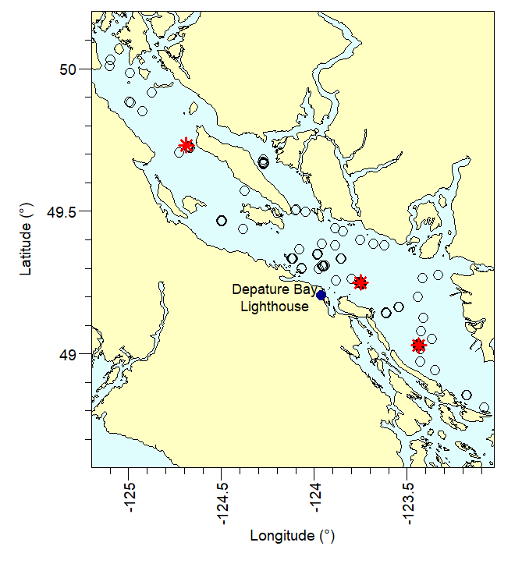
Figure 1. Location of enumerated zooplankton sample stations in the northern, central, and southern Strait of Georgia (2023-2025). Red symbols designate location of productivity stations representing northern, central, and southern regions.
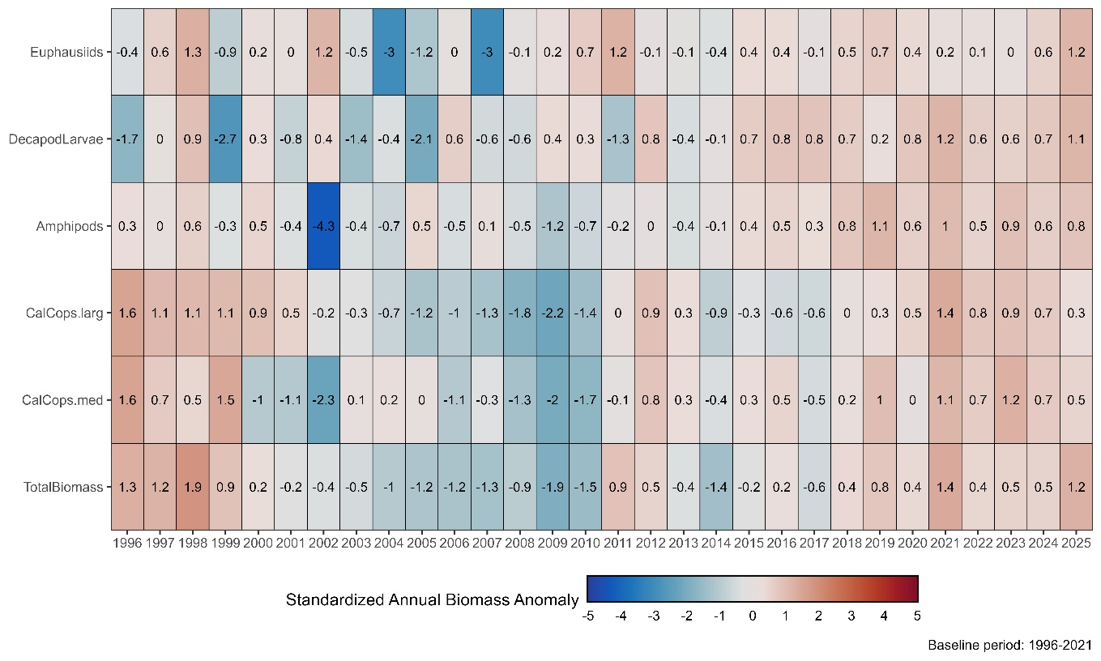
Figure 2. Heatmap of annual biomass anomalies for total zooplankton and crustacean groups common to stomach contents of juvenile salmonids in the Salish Sea (Osgood et al. 2016. Anomalies for each time series are standardized to their respective mean. The number of standard deviations from that mean printed in each box which are colour-scaled accordingly (blue and red shades represent values below and above the climatological mean, respectively.
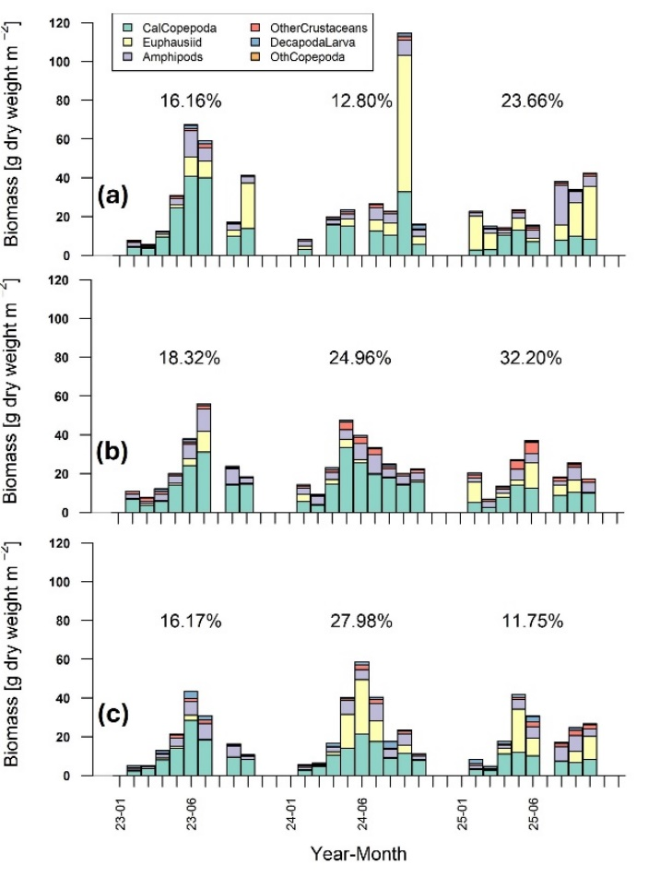
Figure 3. Stacked bar plots of monthly averaged crustacean zooplankton biomass (mg dry weight m⁻²) partitioned into dominant groups in the Salish Sea (as per Young et al. 2023). Annual trophic transfer efficiencies (%) for each regional station, a) northern Station 12; b) central Station GEO1; and c) southern Station 42, are printed above each annual bar plot.

📈 References
Include full references for any publications referenced in other sections. Please format references in Harvard style according to Instructions to Authors for the Canadian Journal of Fisheries and Aquatic Sciences, at Canadian Science Publishing.
Beamish, R.J., and Mahnken, C. 2001. A critical size and period hypothesis to explain natural regulation of salmon abundance and the linkage to climate and climate change. Progress in Oceanography, 49: 423-437

Irvine, J.R., Luedke, W., Pearsall, I., Sastri, A., Carson, C., Menendez, C., Hutchinson, J., Miller-Saunders, K.M., and Hawkins, T. 2024. Marine Risk Assessment for Natural-Origin West
Coast Vancouver Island Chinook Salmon (Oncorhynchus tschawytscha). Can. Tech. Rep.
Fish. Aquat. Sci. 3603: ix + 308 p.

Kolber, Z.S., & Falkowski, P.G. 1993. Use of active fluorescence to estimate phytoplankton photosynthesis in situ. Limnology and Oceanography, 38: 1646–1665.
Mckinnell, S.M. and Mackas, D.L. 2003. Intercalibrating SCOR, NORPAC and bongo nets and the consequences for interpreting decadal-scale variation in zooplankton biomass in the Gulf of Alaska. Fisheries Oceanography, 12: 126-133. https://doi.org/10.1046/j.1365-2419.2003.00227.x

Olson, E. M., S. E. Allen, V. Do, M. Dunphy, and D. Ianson, 2020. Assessment of Nutrient Supply by a Tidal Jet in the Northern Strait of Georgia Based on a Biogeochemical Model. J. Geophys. Res. Oceans.

Osgood, G.J., Kennedy, L.A., Holden, J.J., Hertz, E., McKinnell, S., and Juanes, F. 2016. Historical Diets of Forage Fish and Juvenile Pacific Salmon in the Strait of Georgia, 1966–1968. Marine and Coastal Fisheries. 8: 580-594. DO 10.1080/19425120.2016.1223231

Peña, M. A., Masson, D., & Callendar, W. (2016). Annual plankton dynamics in a coupled physical-biological model of the Strait of Georgia, British Columbia. Progress in Oceanography, 146, 58–74. https://doi.org/10.1016/j.pocean.2016.06.002

Pepin, P., Koen-Alonso, M., Boudreau, S. A., Cogliati, K.M., den Heyer, C.E., Edwards, A. M., Hedges, K. J., and Plourde, S. 2023. Fisheries and Oceans Canada’s Ecosystem Approach to Fisheries Management Working Group: case study synthesis and lessons learned. Can. Tech. Rep. Fish. Aquat. Sci. 3553: v + 67 p

Perry RI, Young K, Galbraith M, Chandler P, Velez-Espino A, et al. (2021) Zooplankton variability in the Strait of Georgia, Canada, and relationships with the marine survivals of Chinook and Coho salmon. PLOS ONE 16(1): e0245941. https://doi.org/10.1371/journal.pone.0245941

Sastri, A.R., and Dower, J.F. 2009. Interannual variability in chitobiase-based production rates of the crustacean zooplankton community in the Strait of Georgia. Marine Ecology Progress Series. 388: 147-157. https://doi.org/10.3354/meps08111

Schreiber, U. 1986. Detection of rapid induction kinetics with a new type of high-frequency modulated chlorophyll fluorometer. Photosynth Res 9: 261–272. https://doi.org/10.1007/BF00029749

Suchy, K.D., Dower, J.F., Varela, D.E., Lagunas, M.G. 2016. Interannual variability in the relationship between in situ primary productivity and somatic crustacean productivity in a temperate fjord. Marine Ecology Progress Series. 545: 91-108 https://doi.org/10.3354/meps11608

Venello, T.A. 2021. Linking zooplankton community composition to ecosystem functioning off the west coast of Vancouver Island and in the northeast subarctic Pacific. PhD Thesis, University of Victoria. https://dspace.library.uvic.ca/items/e81d1081-e7d4-48b5-ab78-f970896d0502/full

Ware, D.M., and Thomson, R.E. 2005. Bottom-Up ecosystem trophic dynamics determine fish production in the Northeast Pacific. Science. 308: 1280-1284. DOI:10.1126/science.1109049

Young, K., Galbraith, M., Sastri, A., and Perry, R.I. Zooplankton status and trends in the central and northern Strait of Georgia, 2022. In Boldt, J.L., Joyce, E., Tucker, S., and Gauthier, S. (Eds.). 2023. State of the physical, biological and selected fishery resources of Pacific Canadian marine ecosystems in 2022. Can. Tech.Rep. Fish. Aquat. Sci. 3542: viii + 312 p.

